Exercise 1: Bayesian inference

07/03/2023 – 14/03/2023

Group D: Clara Kümpel, Damola Agbelese, Yitong Li

* 1. **Maximum likelihood and overfitting**

Polynomial model of order P:

1. Let

Likelihood:

For a single data point y:

For **y** as a vector of data points:

Log-likelihood:

1. Maximum likelihood (ML)

The ML estimator turns out to be the Least Square Error (LSE) estimator.

Written with matrices:

Where

1. Considering the analytic solution is the same as the *polyfit* method in MATLAB:

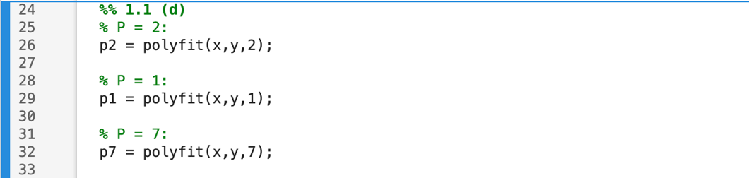

When P = 2, the estimated parameters are much close to the true values.

In this case, estimators with higher P result in higher log-likelihood. All estimators perform not much differently.

1. Using new values of x:

When fitting a new set of data with parameters generated with the other set of data, performances of estimators with P=1 and P=7 drop drastically, which means they do not generalize well when encountering different data sets.

Performance of estimator with P=2 does not change much.

As the order of polynomial term increases, the estimator’s consistency decreases and thus spreads on the histogram across repetitions where different error signals keep being generated.

* 1. **Maximum-A-Posteriori Estimation**

Parameters:

Gaussian prior:

With prior covariance and prior mean

In this exercise,

1. Posterior:

Log-posterior:

1. Maximum-A-Posteriori Estimation:

In our case,

The MAP estimator turns out to be ridge regression (LSE with L2 regularization)

Written with matrices:

Where

Compared to 1.1 (c), estimators of the first three orders keep relatively invariant, yet deviate from the true value more than 1.1 (c).

The norm of the estimator of P=7 is much smaller than 1.1 (c) where the optimization function does not have the regularization term.

MAP estimators keep good consistency across repetitions.

* 1. **Bayesian Inference in the Univariate Gaussian Case**

1. Likelihood:

Given 1 fixed data point

1. Posterior of model parameters

Precision:

Define:

We get:

Define:

We get:

Where: